**Prototype**

**Problem Statement**

In your role as a software developer for the "**Modern Work Opportunity Platform**" project, your task involves creating your project application's homepage. To assist you in this task, I have provided a sample homepage of a well-known Job Opportunity Platform for reference. You can visit <https://www.monster.com/> to gain further details and inspiration for your own project's homepage design.

**Requirements**

The homepage should incorporate the following five essential functionalities:

**User Registration:** This feature should enable users to register and login. A robust backend database should be in place to securely store user details.

**Search Box:** Include a search box that allows users to easily find specific jobs.

**Well-Designed Logo:** Incorporate an attractive and well-designed logo that represents the brand and sets the tone for the website.

**Navigation Menus:** Provide various navigation menus, such as Home, Salary Calculator, Resume Help, Upload Resume, Full Time, Part Time, and Contact Us etc., to help users easily explore different sections of the website.

**Sign up and Login Buttons:** There should be two buttons for user registration and login.

**Note:** You can use any programming language.

Menus

Logo

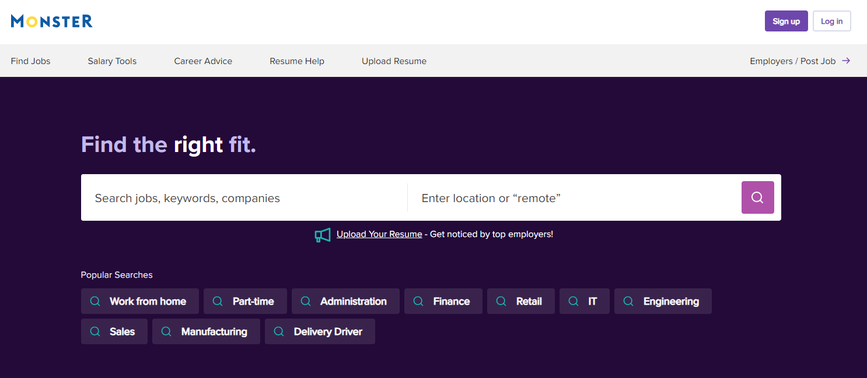

**Figure: Sample Job Opportunity Platform (**<https://www.monster.com/>)